A Mini Project Synopsis on

Academic Task Management System

S.E. – Computer Science and Engineering-Data Science

Submitted By
Riya Rajesh Sawant 21107019
Veena Yogendra Sharma 21107048
Sanika Atul Shelke 21107066
Janvi Dinesh Sharma 21107032

Under The Guidance Of

Prof. Vaibhav Yavalkar

DEPARTMENT OF CSE-DATA SCIENCE
A. P. SHAH INSTITUTE OF TECHNOLOGY
G.B. Road, Kasarvadavali, Thane (W), Mumbai-400615
UNIVERSITY OF MUMBAI

Academic Year: 2022-23

CERTIFICATE

This is to certify that the Mini Project report on Task Management System has been submitted by Riya Rajesh Sawant (21107019), Sanika Shelke (21107066), Janvi Sharma (21107032) and Veena Sharma (2117048) who are Bonafede students of A. P. Shah Institute of Technology, Thane, Mumbai, as partial fulfilment of the requirement for the degree in Computer Science and Engineering (Data Science), during the academic year 2022-2023 in a satisfactory manner as per the curriculum laid down by the University of Mumbai.

Prof. Vaibhav Yavalkar
Guide

Prof. Anagha Aher Dr. Uttam D.Kolekar
Head Department of CSE-Data Science Principal

External Examiner(s)
1.
2.

Place: A. P. Shah Institute of Technology, Thane
Date: 10/11/2022

TABLE OF CONTENTS

1.Introduction............................................................................................................ 1
1.1. Purpose.................................................................................................. 1
1.2. Objectives.............................................................................................. 1
1.3. Scope..................................................................................................... 2
2. Problem Definition………………….................................................................... 3
3. Proposed System………....................................................................................... 5
3.1 Features and Functionality……………………………………………. 6
4. Project Outcomes.................................................................................................. 7
5. Software Requirements ....................................................................................... 9
6. Project Design...................................................................................................... 11
7. Project Scheduling................................................................................................ 14
8. Conclusion............................................................................................................ 17
References ............................................................................................................ 18
Acknowledgement ................................................................................................ 19

Chapter 1:
Introduction

1.1. Purpose
This task management system can be used for the completion of projects/tasks efficiently by organizing and prioritizing related tasks. At every level, task management tools help people work efficiently, reduce waste, stay organized, ensure teams and individuals are being utilized correctly and meet deadlines. This will help students spend more time completing your tasks and less time managing them. It enhances your productivity by helping you effectively track key milestones, set dependencies and accomplish tasks.
The purpose of the Academic Task Management System is to automate the existing manual system with the help of computerized equipment and full-fledged computer software, fulfilling their requirements so that their valuable data/information can be stored for a longer period with easy access and manipulation of the same. The required software and hardware are easily available and easy to work with.

1.2. Objectives
The main objective of this system is to help meet deadlines by managing and organizing their tasks. This system will let the user prioritize important tasks and work accordingly. Our task board lets you prioritize your tasks so you can ensure that the most important things are completed first. Task management tools help end users work smarter, get more done and experience more success. This tool will not only save you time but also increase productivity.

1

The Academic Task Management System has been developed to override the problems prevailing in the practicing manual system. This software is supported to eliminate and, in some cases, reduce the hardships faced by this existing system. Moreover, this system is designed for the need of the education sector to carry out operations in a smooth and effective manner.
It can assist the user to concentrate on their other activities rather concentrate on record keeping. Thus, it will help organizations in better utilization of resources.

1.3. Scope
It may help collect perfect management in details. In a very short time, the collection will be obvious, simple and sensible. It will help a person to know the management of passed year perfectly and vividly. It also helps in current all works relative to Academic Task Management System. It will be also reduced the cost of collecting the management & collection procedure will go on smoothly.
Our project aims at academic process automation, i.e. we have tried to computerize various processes of the Academic Task Management System.
- To assist the students in capturing the effort spent on their respective working areas.
- To utilize resources in an efficient manner by increasing their productivity through automation.
- It satisfies the user requirement.
- Be easy to understand by the user and operator.

2

Chapter 2:
Problem Definition

Currently, people are often stressed out trying to keep up with all the things happening in their life, this tends to them forget about important days/work and miss crucial deadlines. With planning, your time will be spent productively. If students frequently miss deadlines or forget to accomplish tasks, task management tools will help them get organized and stay on track. Our system makes it easy to create a new to-do list, review what you have left on your plate, and mark off what you have already accomplished. There are several benefits to using a task management tool. It can help you stay on top of your workload, boost your productivity and organize your tasks into manageable lists.
The old manual system was suffering from a series of drawbacks. Since whole of the system was to be maintained with hands the process of keeping, maintaining and retrieving the information was very tedious and lengthy. The records were never used to be in a systematic order. There used to be lots of difficulties in associating any particular transaction with a particular context. If any information was to be found it was required to go through the different registers and documents there would never exist anything like report generation. There would always be unnecessary consumption of time while entering records and retrieving records. One more problem was that it was very difficult to find errors while entering the records. Once the records were entered it was very difficult to update these records. The reason behind it is that a lot of information must be maintained and kept in mind while running the business. For this reason, we have provided features present system is partially automated (computerized), existing system is quite laborious as one must enter the same information at different places.

3

Following points should be well considered:
- Details of the information needed for each document and report.
- The required frequency and distribution for each document.
- With the implementation of the computerized system, the task of keeping records in an organized manner will be solved. The greatest of all is the retrieval of information, which will be at the click of the mouse. So the proposed system helps in saving time in different actions and making information flow easy giving valuable reports.
The aim is to automate the existing manual system with the help of computerized equipment and full flat computer software fulfilling their requirements so that their valuable data/information can be stored for a longer period with easy access and manipulation of the same. The project describes how to manage good performance and better services for the students.

4

Chapter 3:
Proposed System

The proposed Academic Task Management System can be used for the completion of projects/tasks efficiently by organizing and prioritizing related tasks. At every level, task management tools help people work efficiently, reduce waste, stay organized, ensure teams and individuals are being utilized correctly, and meet deadlines. Task management system provides the ability to edit, assign and track the project tasks. Tasks are displayed accordingly to make it easy to organize by track, stream or functional area. Tasks can be categorized into different types. This allows you to define different rules, permissions and operations for each of the different task types.
Technical Feasibility:
This included the study of function, performance and constraints that may affect
the ability to achieve an acceptable system. For this feasibility study, we studied
the complete functionality to be provided in the system, as described in the System
Requirement Specification and checked if everything was possible using a different type of frontend and backend platforms.
Operational Feasibility:
No doubt the proposed system is fully GUI based is very user friendly and all inputs to be taken all self-explanatory even to a layman. Besides, proper training has been conducted to let them know the essence of the system to the users so that they feel comfortable with the new system. As far as our study is concerned the clients are comfortable and happy as the system has cut down their loads and doing.

5

3.1. Features and functionality
1. Reminders in the form of pop-ups to notify you about your upcoming tasks and deadline
2. After signing in admin can add a task or delete the task.
3. Students can view their upcoming tasks to complete their work.
4. Number of upcoming tasks can also be viewed in the admin’s module.
5. Recent tasks or pending tasks can also be viewed since they are sorted by dates.
6. Admin can add, manage and delete tasks.

6

Chapter 4:
Project Outcomes

The purpose of the Academic Task Management system is to automate the existing manual system with the help of computerized equipment and full-fledged computer software and fulfilling their requirements so that the valuable data information can be stored for a long walk period with easy access and manipulation of the same. The required software and hardware ensure easily available and easy to work with.
The academic management system as described above can lead to an error-free reliable and fast management system. It can assist the user to concentrate on their other activities rather than concentrate on record keeping. Thus, it will help the organization in better utilization of resources. The organization can maintain computerized records with redundant entries which means that one need not be distracted by information that is not relevant while being able to reach information.
The new system proposed and then developed by me will ease the task of the organization in consideration. It will be helpful in generating the required reports by the staff, which will help them to track their progress and services. Thus, it will ease the task of Management to a great extent as all the major activities to be performed, are computerized through this system.
The outcome of the project ensured the following: the user understands the importance of time management which is a very useful tool for academic success, creating a list of tasks was accomplished, Time management, and efficient and effective utilization of available resources, Attention of school activity to every Subject and school activity ensures regular and balanced progress, planning for the achievement of objectives, an orderly arrangement of the division of time adapted to the purposes of civil life as years months weeks and days is also a register of the year with division and academics,

7

the Academic Task Management System serves as an information source and planning document for students, faculty, staff and the department, the calendar includes a registration schedule, admission-curricular, start of the academic year, curricular and co-curricular activities, (weekly, monthly and annually) formative and summative assessment and evaluation examination schedule, there are pop-ups and notifications all lined up 1-2 before the event so one need not set a reminder.

8

Chapter 5:
Software Requirements

The Software Requirements Specification is produced at the culmination of the analysis task. The function and performance allocated to software as part of system engineering are refined by establishing a complete information description, a detailed functional and behavioural description, an indication of performance requirements and design constraints, appropriate validation criteria, and other data pertinent to requirements.

- The proposed system has the following requirements:

- System needs to store information about the student when they create a new account.

- System needs to display task details when the display data function is implemented.

- System needs to allow the admin to update, delete or add data.

- System needs to ensure that reminder notifications are implemented and displayed at the scheduled time.

There has been a continuous effort to develop tools that can ease the software development process But, with the evolving trend of different programming paradigms today’s software developers are really challenged to deal with the changing technology. Among other issues, software re-engineering is regarded as an important process in the software development industry.

9

One of the major tasks here is to understand software systems that are already developed and to transform them to a different software environment. Generally, this requires a lot of manual effort in going through a program that might have been developed by another programmer. This project makes a novel attempt to address the issue of program analysis and generation of diagrams, which can depict the structure of a program in a better way.

Software Requirements:

Name of the component | Specification
Operation System | Windows 10
Language | Java
Database JDBC | MySQL Connector
Software Development Kit | Java JDK 18.0.1
Java IDE | NetBeans 14

10

Chapter 6:
Project Design

6.1. Standard Design:
The system is designed with several interaction cues on each page that makes up the Academic Task Management System. These cues are well-defined such as to make several functionalities that the system exposes to collect, process and output data. Access to these functionalities is made possible by the well-designed user interface which embodies several technologies to process data. The system is built in a modular form where these functionalities are built into modules. Some of the modules are as follows:
1. View Tasks.
2. Manage Tasks.
3. Manage Students.
4. Admin Login.
5. User Login.
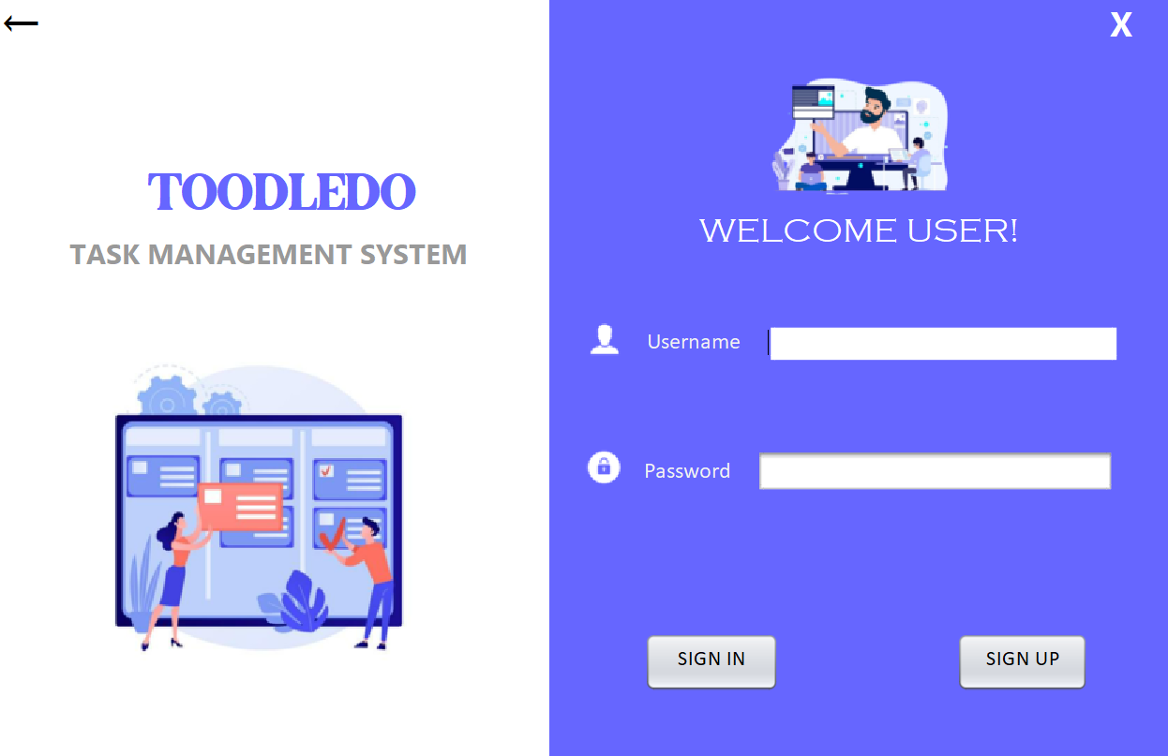
Figure 6.1
11

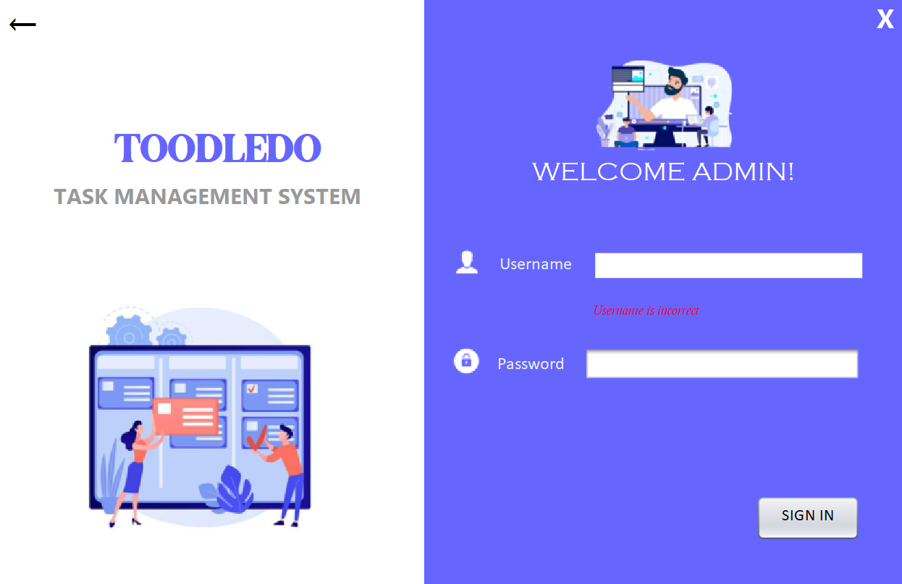 Figure 6.2

Output Specification:
The system is designed in such a way that it efficiently provides output to the user promptly and in a well-organized manner. The format for the several outputs is
made available on the output pages.
1. View Tasks: Admin and User can view the list of tasks that are pending. Tasks are arranged in an orderly manner so that it helps users to anticipate tasks quickly.

2. Add Task: Admins can easily add tasks for the user with specific dates.

3. Delete Tasks: Admin has the access to delete the tasks.

12

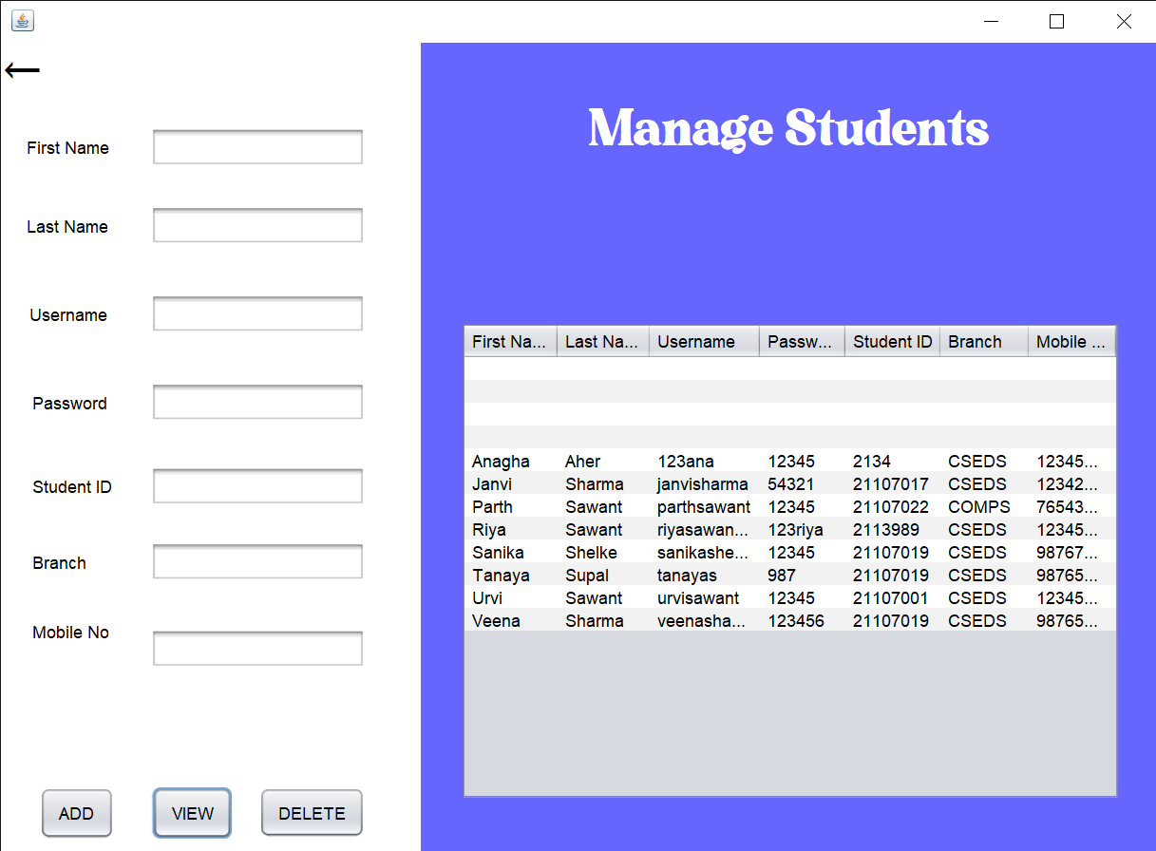
Figure 6.3

Input Specification
The system is designed to accept several input details efficiently through input forms and user clicks. The data captured through the user keystrokes and clicks are received by specific modules on the system and relayed to the system’s back end for processing. Input is collected using the following page modules:
1. User Profile: This is used to view the account details like – Name, Student ID and mobile no., Also user is provided with the option of adding a profile and deleting the account.
2. Admin login: This is used to capture information about the administrative personnel who controls content and display on the system.

12

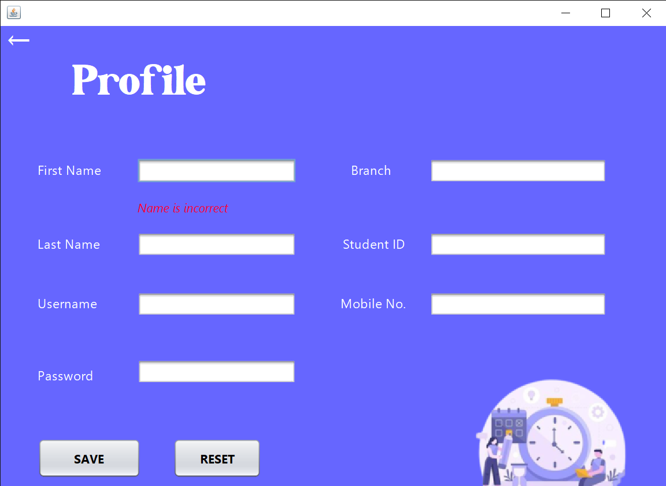
Figure 6.4

Database Specification
The database system used to implement the back end of the Academic Task Management System is MySQL Workbench. Access to the system was made possible by a graphical interface (NetBeans) with Java JDK. The database name is SQL Schemas and the structure of the data tables in the database is as follows:
- admin_info
- student_task
- tasks

13

Chapter 7:
Project Scheduling

Sr. No | Group Member | Time Duration | Work to be done
1 |  | 1st week of July | Group formation and Topic finalization. Identifying the scope and objectives of the Mini Project.  Discussing the project topic with the help of a paper prototype.
1 |  | 1st week of August | Identifying the functionalities of the Mini Project.  Designing the Graphical User Interface (GUI).
2 |  | 2nd week of August | Database Design
3 |  | 3rd week of August | Database Connectivity of all modules.
4 |  | Last week of September | Integration of all modules and Report Writing.

An elementary Gantt chart or Timeline chart for the development plan is given ahead. The plan explains the tasks completed over the course of this semester.

14

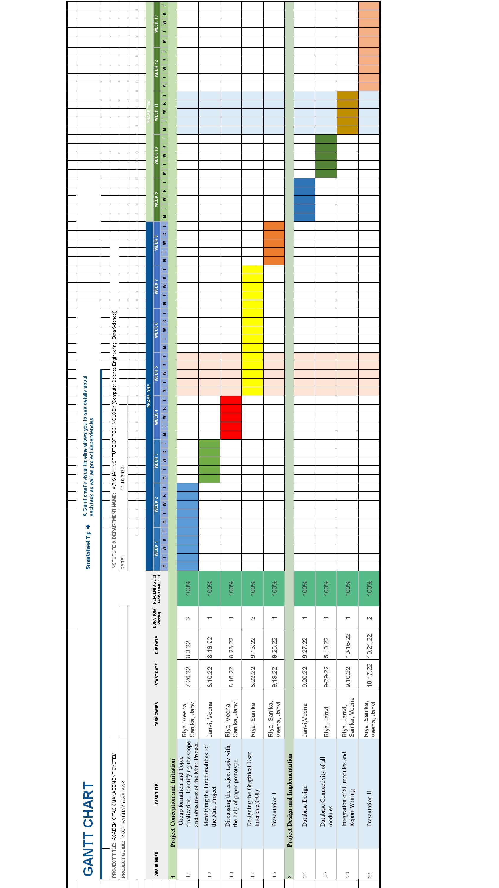

Figure 7.1
15

Here in the above figure 7.1, the rows of the chart contain the task titles such as the project conception and initialization as well as the project design and implementation which in subdivision contains the group formation, topic finalizing, prototype, GUI designing, backend implementation etc. The columns contain the duration of the task completed, percentage of work completed, number of weeks required to complete a particular task, the specific dates, the team members who contributed towards the completion of tasks

The detailed explanation of the Gantt chart is explained below: The project conception and initiation task was executed by the July month end around 26/07/2022. The task of initiation included many more sub-tasks such as group formation and topic finalization which was performed during the 1 week of project initialization. The group formed included 4 members Riya Sawant, Veena Sharma, Sanika Shelke, Janvi Sharma and the finalized topic was An Academic Task Management System. Further, the upcoming week led to the task of identifying the scope and objectives of the mini-projects.This was during the time interval of (26/07/2022-03/08/2022).
The next sub-task was to identify the functionalities of the project which was done by the two members Janvi Sharma and Veena Sharma in a span of one week from 10/08/2022 to 16/08/2022.

The discussion of the project topic with the help of a paper prototype was completed with equal contribution from all the group members within one week from 16/08/2022 to 23/08/2022.

The next main task of Graphical User Interface (GUI) designing was completed by Sanika Shelke and Riya Sawant within 3 weeks from 23/08/2022 to 13/09/2022. The next week from 19/09/2022 to 23/09/2022 the members worked on the preparation of Presentation I.

The next major task was database design and implementation. It took all 5 weeks to complete the final implementation. The database Design and connectivity of all modules were done by Riya Sawant, Janvi Sharma and Veena Sharma during the course time of 3 weeks from 20/09/2022 to 05/10/2022. The integration of all modules and report writing was completed by all the group members from 09/10/2022 to 16/10/2002. The preparation of final presentation II work was equally shared by all the group members in the time of 2 weeks from 17/10/2022 to 21/10/2022.

16

Chapter 8:
Conclusion

The development of the Academic Task Management System involved many phases. The approach used is a top-down one concentrating on what first, then how and moving to successive levels of details. Task management tool lets you keep track of deadlines. It also helps you keep track stay organized and increase productivity.
This academic task management tool will let the respective faculties assign academic tasks to their students to help them keep track of their upcoming and overdue tasks to complete their work accordingly.
This system is a task manager for all the events that occur in an academic year, and will help students, faculty and staff keep track of the key dates throughout the academic semester.

17

References:
1. https://youtu.be/QYDycJhyIv4
2. https://youtu.be/54yGDNLjzro
3. https://drive.google.com/file/d/12gWuIBbL6PVl0SrWw7jOcAAFDFHuIkn5/view
4. https://youtu.be/pP9uyhOYVnM
5. https://www.tutorialspoint.com/swingexamples/show_alert_message_dialog.htm#
6. https://drive.google.com/file/d/1UzBy_Tf6xNGNsGL-xb1O2hho9_QYI7c0/view
7. https://drive.google.com/file/d/1MRHtewqr0n2BYZpCEM39vUBMfroSdaZE/view
8. https://drive.google.com/file/d/12gWuIBbL6PVl0SrWw7jOcAAFDFHuIkn5/view
9. https://youtu.be/OsgX1grOJZA
10. https://youtu.be/CQMpXGwHeYQ

18

Acknowledgement

This project would not have come to fruition without the invaluable help of our guide Prof. Vaibhav Yavalkar. Expressing gratitude towards our HoD, Prof. Anagha Aher, and the Department of Computer Science and Engineering-Data Science for providing us with the opportunity as well as the support required to pursue this project. We would also like to thank our teachers Ms Rajashri Chaudhari and Ms Poonam Pangarkar who gave us their valuable suggestions and ideas when we needed them. We would also like to thank our peers for their helpful suggestions.

19

